|  |  |  |  |
| --- | --- | --- | --- |
| **NAME:** | Lauron, John Enrico D. | **DATE:** | 10/09/2023 |

ALGORITHM EXERCISE # 5.1

LE 5.11: **Average of Even Numbers and Product of Odd Numbers (Pseudocode)**

START

1. INITIALIZE evenSum as 0
2. INITIALIZE oddProduct as 1
3. INITIALIZE evenCount as 0
4. INITIALIZE numbers as 10
5. INITIALIZE average as float
6. PROMPT and READ integer, i
7. FOR i = 1; i < 11; i++ DO
   1. DISPLAY input integers, numbers [ i ]
8. FOR int i = 1; i < 11; i ++ DO
   1. IF numbers [ i ] is divisible by 2 THEN
      1. FIND the sum of the even numbers, evenSum
      2. evenCount++
   2. ELSE
      1. FIND the product of the odd numbers, oddProduct *= numbers [ i ]
   3. ENDIF
9. ENDFOR
10. COMPUTE the average of all even numbers, evenSum / evenCount
11. IF oddProduct is equal to 1 and evenSum is greater than 0
    1. DISPLAY the average of all even integers
    2. DISPLAY the product of all odd integers is 0
12. ELSE IF oddProduct is not equal to 1 and evenSum is equal to 0
    1. DISPLAY the average of all even integers is 0
    2. DISPLAY the product of all odd integers
13. ELSE
    1. DISPLAY the average of all even integers and the product of all odd integers
14. ENDIF

END

LE 5.11: **Average of Even Numbers and Product of Odd Numbers (Flowchart)**

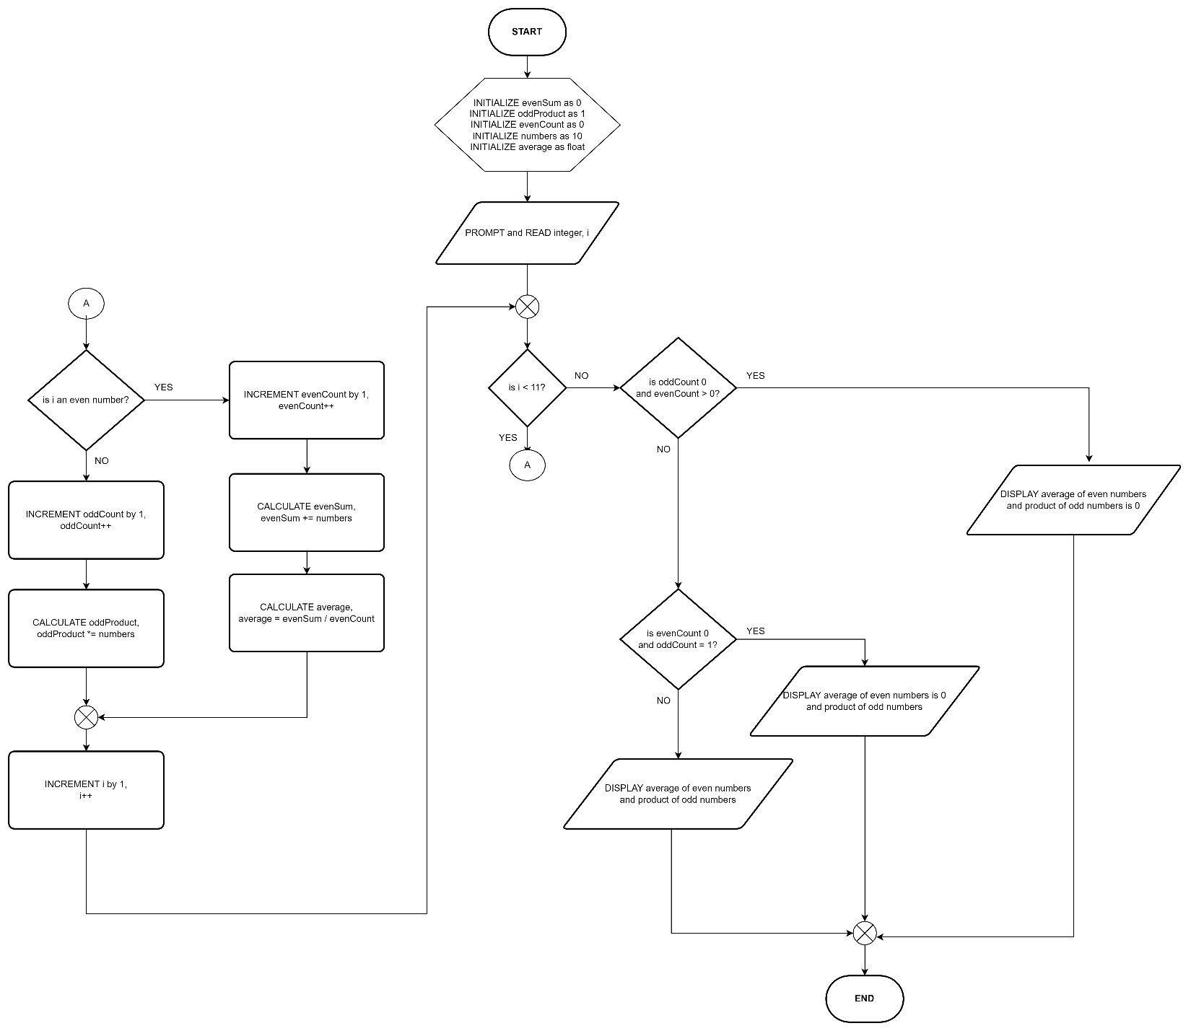

LE 5.12: **Passcode Lock (Pseudocode)**

START

1. INITIALIZE 828 as PASSCODE
2. INITIALIZE attempts to 1
3. PROMPT and READ passcode
4. WHILE passcode is not equal to PASSCODE and attempts is less than 3
   1. DISPLAY incorrect passcode you have more attempts, 3 – attempts
   2. attempts++
   3. PROMPT and READ the numeric passcode
5. IF passcode is equal to PASSCODE THEN
   1. DISPLAY ACCESS GRANTED
6. ELSE
   1. DISPLAY ACCESS DENIED
7. ENDIF
8. ENDWHILE

END

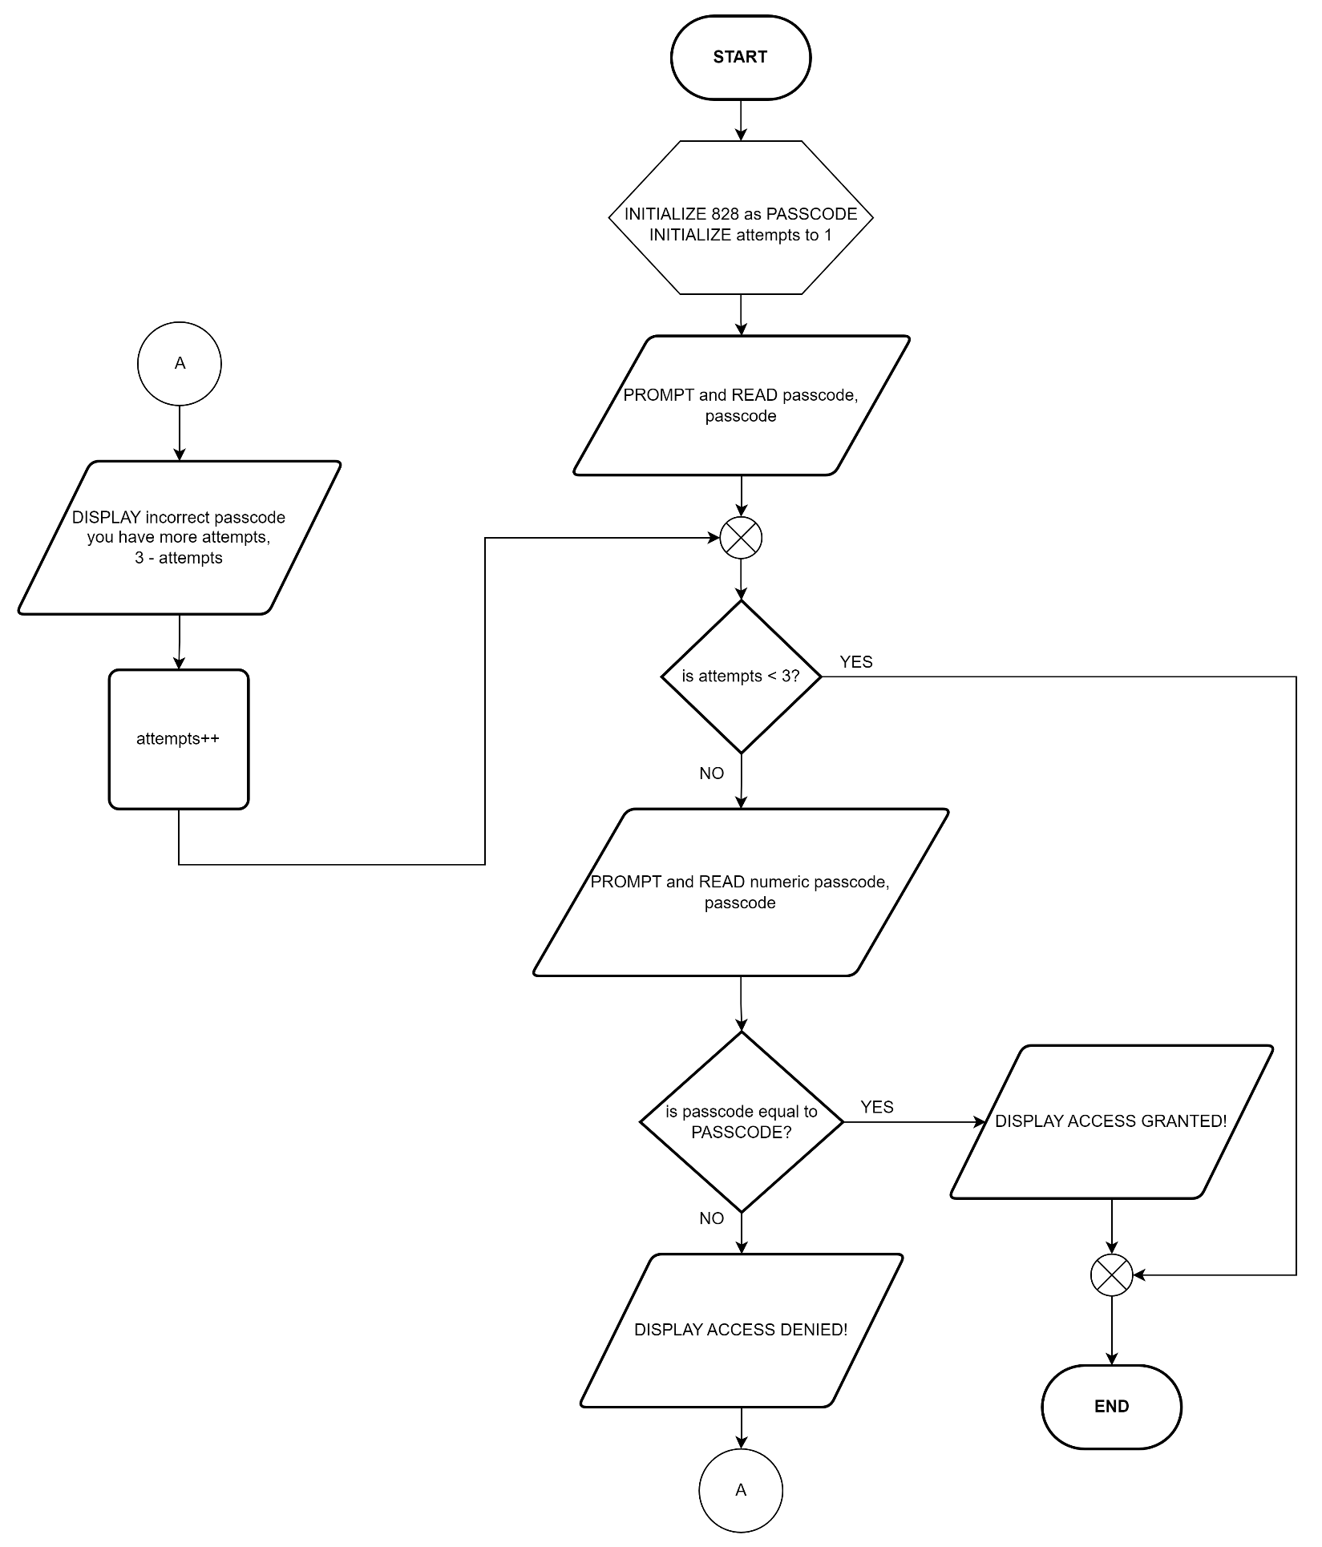LE 5.12: **Passcode Lock (Flowchart)**

LE 5.13: **Problem Solver Menu (Pseudocode)**

START

1. DO
   1. PROMPT and GET the user’s choice for the problem solvers, choice
   2. IF choice is equal to 1 THEN
      1. PROMPT and READ base, base
      2. PROMPT and READ exponent, exponent
      3. CALCULATE result, result = base^exponent
      4. DISPLAY result
   3. ELSE IF choice is equal to 2 THEN
      1. INITIALIZE factorial as 1
      2. PROMPT and READ number, n
      3. FOR count = 1; count <= n; i++ DO
      4. CALCULATE factorial, factorial *= count
      5. DISPLAY factorial
2. ENDFOR
3. ELSE IF choice is equal to 3 THEN
   1. INITIALIZE a,b,c,discriminant,root1,root2 as float
   2. PROMPT and READ the value of a, c
   3. PROMPT and READ the value of b, c
   4. PROMPT and READ the value of c, c
   5. CALULATE discriminant, discriminant = b * b – 4 * a * c
4. IF (a and b is equal to 0) THEN
   1. DISPLAY there is no solution
5. ELSE IF (a is equal to 0) THEN
   1. CALCULATE root1, root1 = -1 * c / b
   2. DISPLAY there is only one root
6. ELSE IF (discriminant is less than 0) THEN
   1. DISPLAY there are no real roots
7. ELSE
   1. CALCULATE root1, root1 = (-1 * b + sqrt(discriminant)) / (2 * a)
   2. CALCULATE root1, root1 = (-1 * b - sqrt(discriminant)) / (2 * a)
   3. IF (root1 is equal to root2)
      1. DISPLAY one solution found
   4. ELSE
      1. DISPLAY two solutions found
8. ENDIF
   1. ELSE IF choice is equal to 4 THEN
      1. DISPLAY thank you for using ScarMath
   2. ELSE
      1. DISPLAY please enter numbers 1 – 4 only
9. WHILE choice is not equal to 4

END

LE 5.13: **Problem Solver Menu (Flowchart)**

